Provider and Configuration Setup
To begin with, I started with Terraform which is the core of the project – a working IaC that someone could deploy. I created the providers.tf and variables.tf configurations
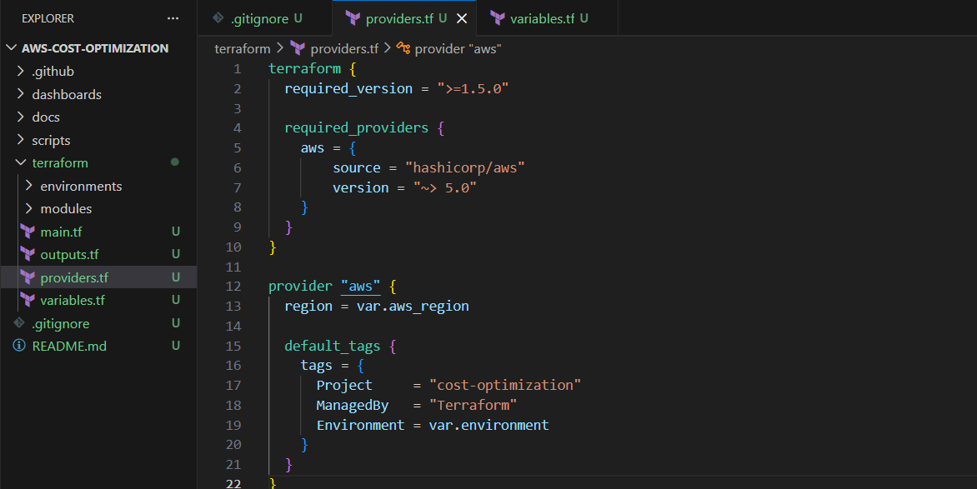

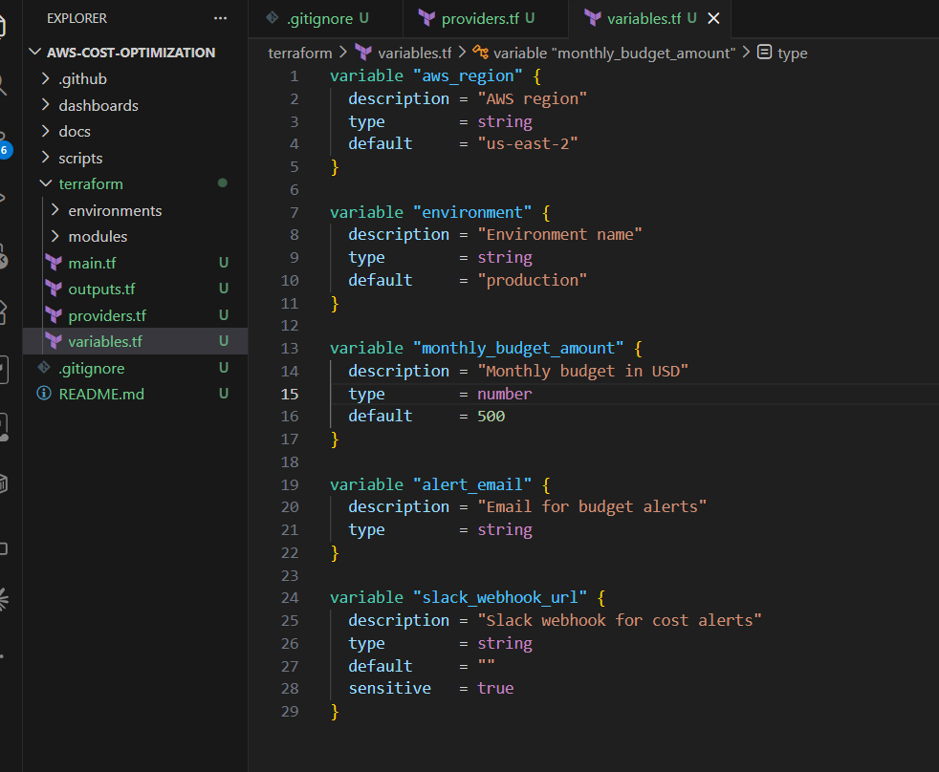

Budget Alerts Module
I created a budget alert folder which consist of terraform/modules/budget-alerts/main.tf and terraform/modules/budget-alerts/variables.tf . terraform/modules/budget-alerts/main.tf consist of three (3) AWS resources that work together as the cost monitoring system.
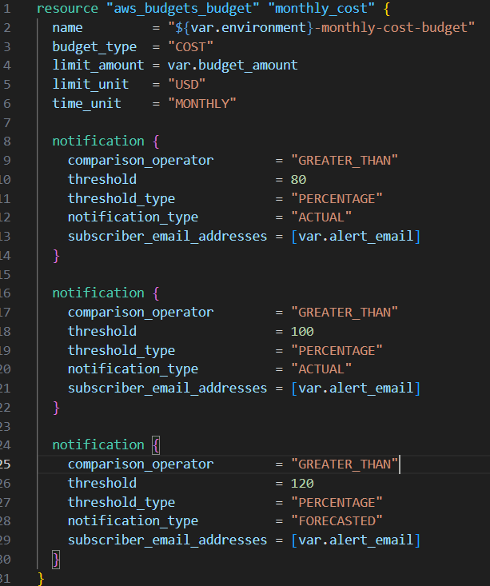
Resource 1 "aws_budgets_budget" "monthly_cost"
This creates an AWS Budget; a spending cap with email alerts. You’ll notice three notification blocks and each blocks defines a trigger condition and who gets alerted.
First notification (80% actual) — This fires when your real, already-incurred spend exceeds 80% of the budget. If your budget is $500, you get an email when you've spent $400. This is your early warning — you still have runway to investigate and act before hitting the limit. The notification_type = "ACTUAL" means it's based on what you've already spent, not a projection.
Second notification (100% actual) — This fires when you've blown through the full budget. At $500 spend, you get the email. At this point you're over budget and need to take immediate action — stop unused resources, check for runaway services, etc.
Third notification (120% forecasted) — This one is different. notification_type = "FORECASTED" means AWS uses your spending trend to predict where you'll land by month-end. If you're on day 10 and burning fast enough that AWS projects, you'll hit 120% ($600) by the 30th, you get the alert now — even though you might only be at $200 currently. This is your most proactive alert because it gives you the most time to react.

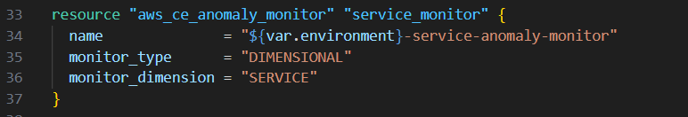
Resource 2: aws_ce_anomaly_monitor "service_monitor"
This creates a Cost Explorer Anomaly Monitor — an ML-powered system that learns your normal spending patterns and flags deviations. monitor_type = "DIMENSIONAL" — This tells AWS to analyze cost anomalies broken down by a specific dimension. The alternative is CUSTOM, where you'd define your own cost category filters. monitor_dimension = "SERVICE" — The dimension to watch is AWS service type. So if your EC2 spend is normally $200/month and suddenly jumps to $350 in a week, the ML model flags it as anomalous. It monitors each service independently — a spike in S3 costs won't be masked by a drop in RDS costs.

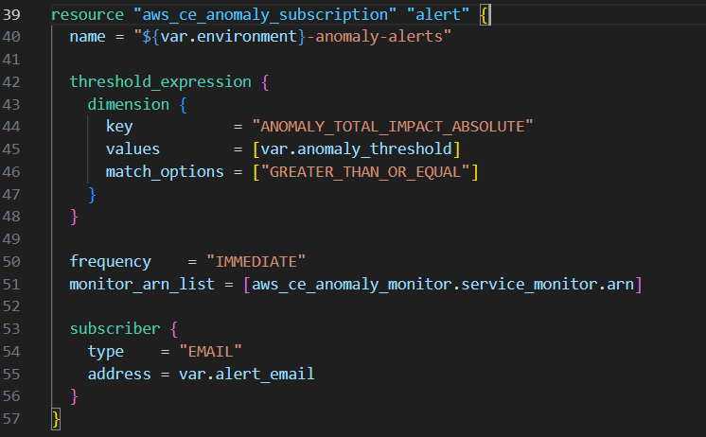

Resource 3: aws_ce_anomaly_subscription "alert"
This connects the anomaly monitor to an actual notification channel. It's the "when you detect something weird, tell me" part.
threshold_expression — This is the filter that controls which anomalies you actually get notified about. Without it, you'd get alerts for every tiny fluctuation.
The key is ANOMALY_TOTAL_IMPACT_ABSOLUTE — this means "the dollar amount of the anomaly." If var.anomaly_threshold is "50", you only get alerted when the anomaly represents $50 or more in unexpected spend. A $3 blip gets ignored. This prevents alert fatigue.
frequency = "IMMEDIATE" — Send the alert as soon as the anomaly is detected, don't batch them into a daily or weekly digest. For cost spikes, you want to know right away.
monitor_arn_list = [aws_ce_anomaly_monitor.service_monitor.arn] — This links the subscription to the monitor I created above. The .arn is Terraform's way of referencing the Amazon Resource Name that AWS assigns to the monitor after it's created. This is a dependency — Terraform knows it must create the monitor first, then the subscription.
subscriber — Where to send the alert. type = "EMAIL" with address = var.alert_email sends anomaly notifications to the same email as your budget alerts. You could also use type = "SNS" to send to an SNS topic, which could then fan out to Slack, PagerDuty, or Lambda for custom processing.

Tagging Enforcement Module
This section sets up AWS Config to continuously monitor the resources and flag any that are missing mandatory cost-allocation tags. It consists of six (6) resources plus a locals block and they form a dependency chain- each one builds on the previous.

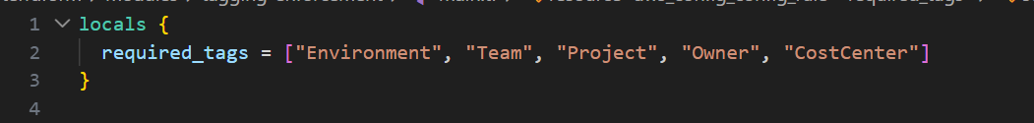
The locals Block
This defines a local variable — a list of the five tag keys which is considered mandatory for cost tracking. It's not directly consumed by any resource in this file (the input_parameters block in “Resource 1” hardcodes them individually because the AWS Config rule expects tag1Key, tag2Key, etc.), but it serves as documentation and could be referenced elsewhere for validation logic. Think of it as the single source of truth for "these are the tags every resource must have."

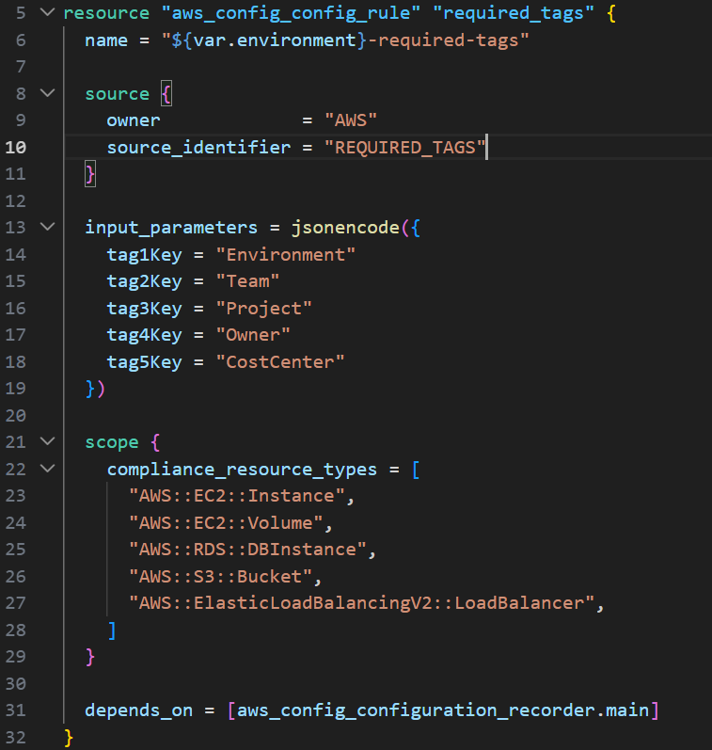
Resource 1: aws_config_config_rule "required_tags"
name = "${var.environment}-required-tags" — Environment-prefixed name, so production and staging can each have their own rule in the same account.

In the source Block, owner = "AWS" means I’m using a managed rule — one that AWS has pre-built and maintains for you. You don't write the evaluation logic yourself. The alternative is CUSTOM_LAMBDA, where you'd write your own Lambda function to evaluate compliance.
source_identifier = "REQUIRED_TAGS" tells AWS Config which managed rule to use. REQUIRED_TAGS is one of dozens of managed rules AWS provides. It checks whether resources have specific tag keys present.

The input_parameters Block passes configuration to the managed rule. The REQUIRED_TAGS rule supports up to six tag keys (tag1Key through tag6Key). I required five. jsonencode() converts the Terraform map into a JSON string, which is the format AWS Config expects for rule parameters. When the rule evaluates an EC2 instance, it checks: does this instance have a tag called "Environment"? Does it have "Team"? "Project"? "Owner"? "CostCenter"? If anyone is missing, the resource is marked NON_COMPLIANT in the AWS Config dashboard.

The scope Block, limits which resource types the rule evaluates. Without a scope, it would try to check everything — including resources that might not support tags or that you don't care about tagging. You're targeting the five resource types that typically drive the most cost in a SaaS environment: EC2 instances, EBS volumes, RDS databases, S3 buckets, and Application Load Balancers.
depends_on = [aws_config_configuration_recorder.main] — This explicit dependency tells Terraform: "Don't create this rule until the configuration recorder exists and is set up." AWS Config rules can't function without a recorder running, so Terraform needs to create that first.
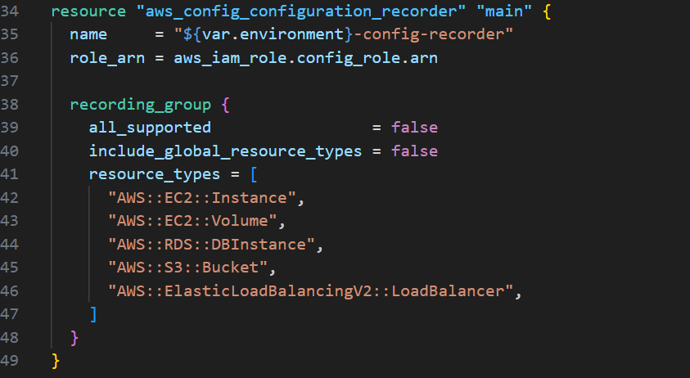
Resource 2: aws_config_configuration_recorder "main"
This is the engine of AWS Config — it's what actually watches AWS resources and records their configuration state over time. role_arn gives the recorder an IAM role so it has permission to read your AWS resources. The .arn reference means Terraform will automatically create the IAM role first (defined later in this section), get its ARN, and pass it here. This is an implicit dependency — Terraform's dependency graph handles the ordering without you needing depends_on.
In the recording_group Block, all_supported = false — this is telling Config NOT to record every resource type in your account. If this were true, Config would track hundreds of resource types (IAM policies, security groups, Lambda functions, etc.), which generates a lot of data and increases cost. By setting it to false and specifying a list, you keep the Config charges low.
include_global_resource_types = false — Global resources are things like IAM users and roles, which exist at the account level rather than in a specific region. You don't need to tag-check those for cost allocation purposes, so you exclude them.
resource_types — The same five types from the rule's scope. The recorder and the rule need to match — there's no point having a rule that evaluates S3 buckets if the recorder isn't tracking S3 buckets.

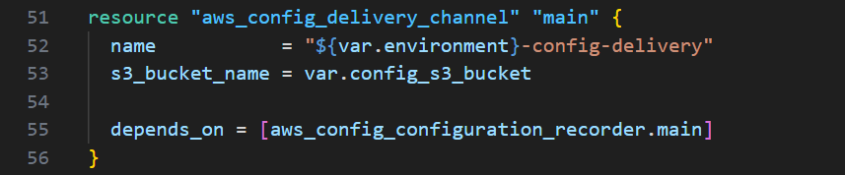
Resource 3: aws_config_delivery_channel "main"
AWS Config needs somewhere to store configuration snapshots and compliance history. The delivery channel tells it to write that data to an S3 bucket. var.config_s3_bucket comes from the root module's main.tf, which creates a bucket specifically for this purpose.
The depends_on ensures the recorder exists before the delivery channel is created — AWS requires this ordering. Without a recorder, a delivery channel has nothing to deliver.

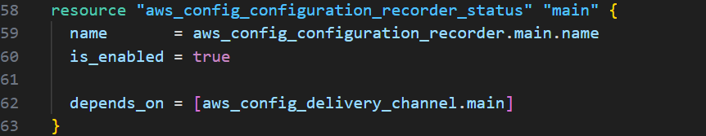
Resource 4: aws_config_configuration_recorder_status "main"
creating a recorder doesn't automatically start it. This resource flips the switch to is_enabled = true. It's a separate resource because Terraform needs the recorder and delivery channel to both exist before it can enable recording.
The dependency chain here is important: IAM role → recorder → delivery channel → recorder status. Each depends_on enforces the correct creation order. If Terraform tried to enable the recorder before the delivery channel existed, the API would return an error.

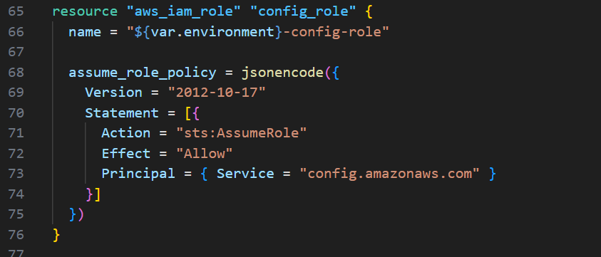
Resource 5: aws_iam_role "config_role"
This creates the IAM role that the Config recorder uses to read the resources. The assume_role_policy is a trust policy — it defines who is allowed to assume (use) this role.
Principal = { Service = "config.amazonaws.com" } means only the AWS Config service can assume this role. A human user, a Lambda function, or any other service cannot. Action = "sts:AssumeRole" is the specific API call that Config makes to temporarily take on this role's permissions. Effect = "Allow" permits it.
This trust policy doesn't grant any actual permissions — it just establishes the trust relationship. The actual permissions come from the next resource.

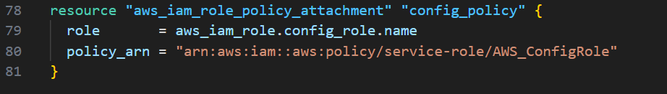
Resource 6: aws_iam_role_policy_attachment "config_policy"
This attaches an AWS-managed policy to the role. AWS_ConfigRole is a pre-built policy that grants read-only access to the resources Config needs to inspect — it can describe EC2 instances, list S3 buckets, read RDS configurations, etc., but it can't modify or delete anything.
By using the managed policy instead of writing a custom one, you ensure the permissions stay up to date as AWS adds new resource types. AWS maintains this policy and updates it when new services launch.

Scheduled Shutdown Module (Lambda)
This section contains a file “terraform/modules/scheduled-shutdown/main.tf” that creates an automated scheduling system that stops non-production resources after business hours and starts them in the morning. It has ten resources organized into four logical groups: packaging, Lambda functions, schedules, and permissions.
It also contains a Python script file “terraform/modules/scheduled-shutdown/lambda/shutdown.py” - This is the Python code that runs inside your Lambda functions. It's the actual logic that stops and starts your EC2 instances and RDS databases.

Root Module (Wiring It Together)
This section contains a file terraform/main.tf — the orchestration file that wires all three modules together and creates the shared resources they depend on. This root module is the control plane for your entire cost optimization stack. It creates one shared resource (the S3 bucket), looks up one piece of account information (the account ID), and then passes the right configuration into each of the three specialized modules.
The dependency flow is: the data source resolves first (account ID lookup), then the S3 bucket is created (needs account ID for the name), then the bucket policy is attached, and then the three modules initialize in parallel since budget_alerts and scheduled_shutdown don't depend on the S3 bucket — only tagging_enforcement does. Terraform figures out this parallelism automatically.

HANDS-ON
I ran aws ec2 run-instances --image-id ami-0f2afc310ea592067 --instance-type t3.micro --count 1 --tag-specifications "ResourceType=instance,Tags=[{Key=AutoShutdown,Value=true},{Key=Name,Value=dev-wasteful-instance},{Key=Environment,Value=dev}]" --region us-east-2 to lunch a free Tier EC2 instance with the AutoShutdown Tag

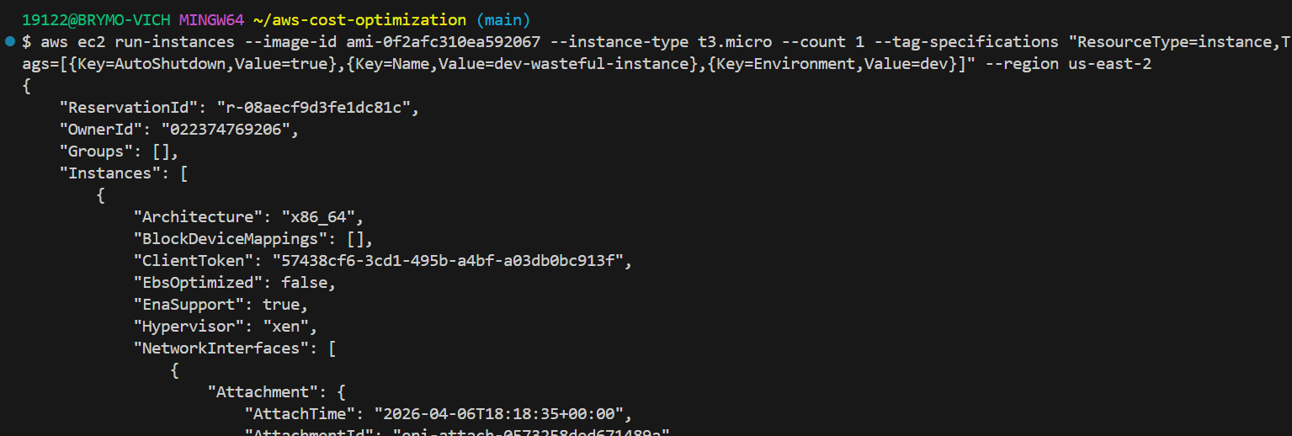

Ran aws ec2 create-volume --availability-zone us-east-2a --size 10 --volume-type gp3 --tag-specifications "ResourceType=volume,Tags=[{Key=Name,Value=orphaned-volume}]" --region us-east-2 to create an unattached EBS volume(orphaned waste)
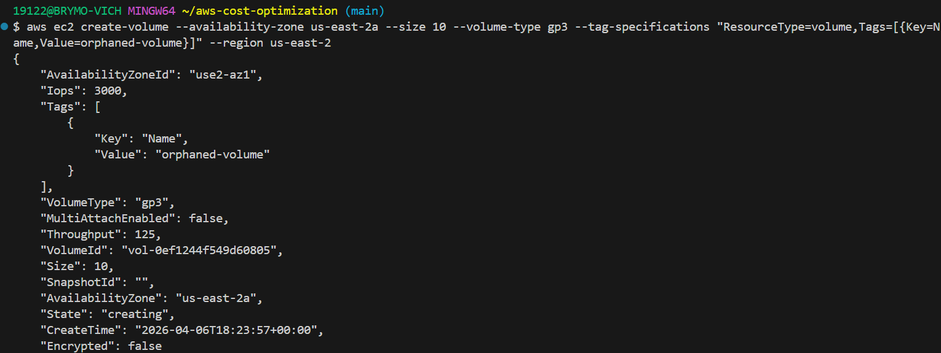

I ran aws ec2 allocate-address --domain vpc --region us-east-2 to allocate an Elastic IP without associating it. An unassociated Elastic IP costs $0.005/hour (~$3.60/month) and serves no purpose — it's just sitting there burning money. This is one of the most common forms of AWS waste in real environments. Someone launches an instance, allocates an EIP, terminates the instance later, and forgets to release the EIP. It keeps billing quietly.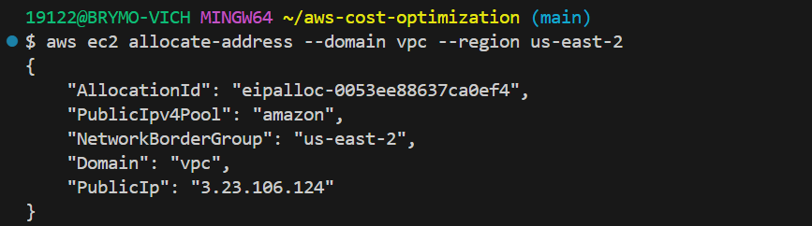

Resources were created successfully
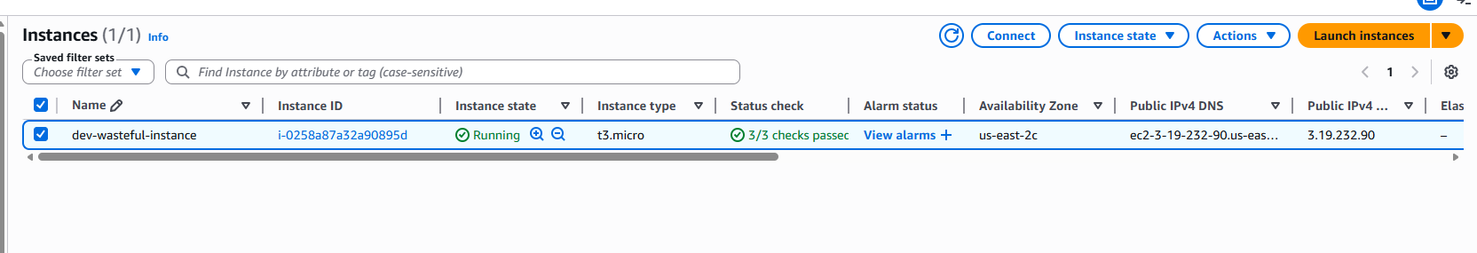
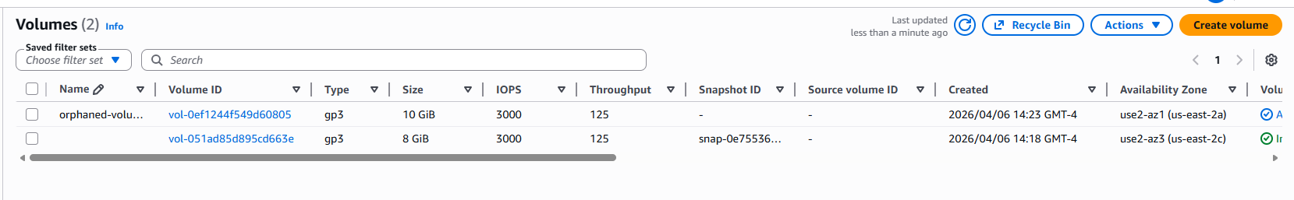
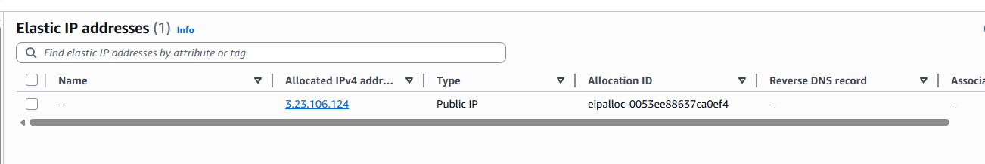

I ran the command python scripts/audit/cost_audit.py --region us-east-2 against the wasteful resources to show the audit script.
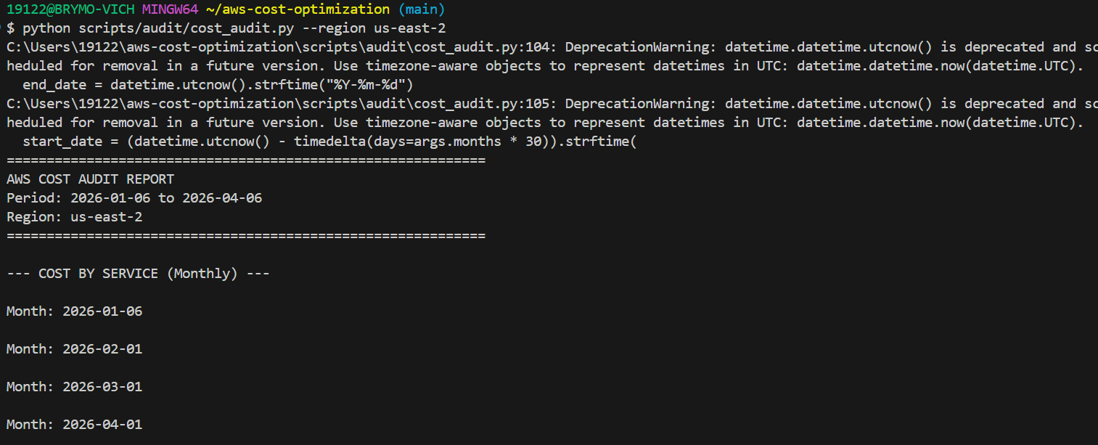
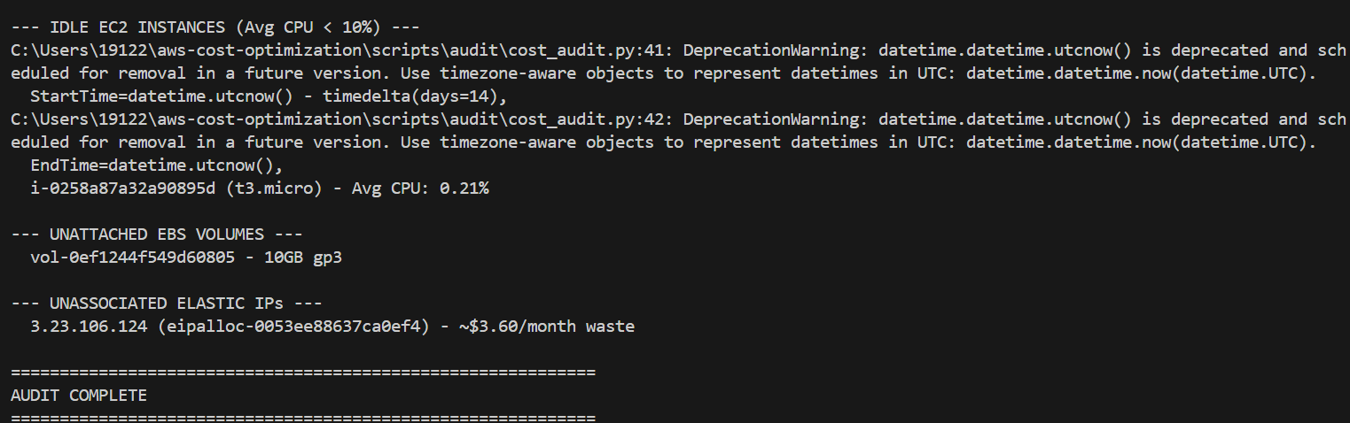

Here is a clean output with no warnings
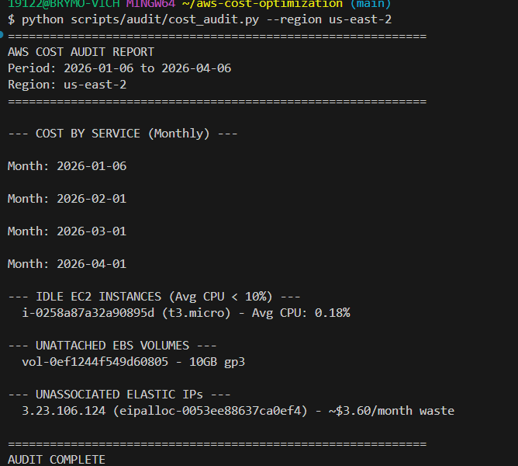

I ran python scripts/cleanup/delete_orphaned_resources.py --region us-east-2 to show exactly what would be cleaned up.
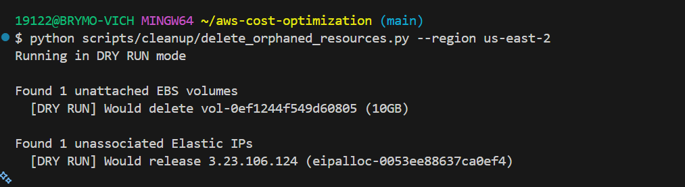

Deploying Terraform Stack
In terraform directory, I ran cp example.tfvars terraform.tfvars then replaced xxxx@example.com with my email in terraform.tfvars – which is gitignored.

Prove that all resources deployed successfully
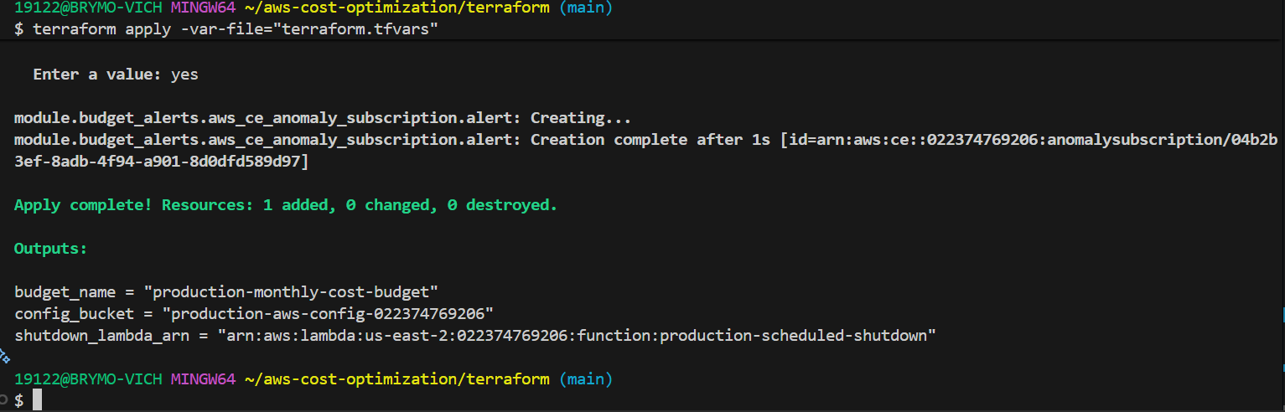

Screenshot of budget
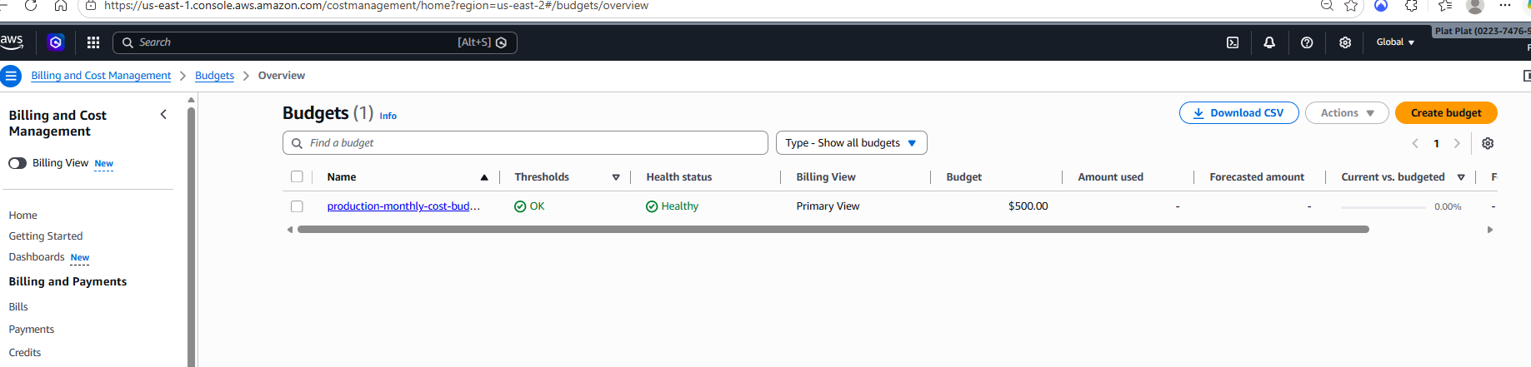

Screenshot for aws config
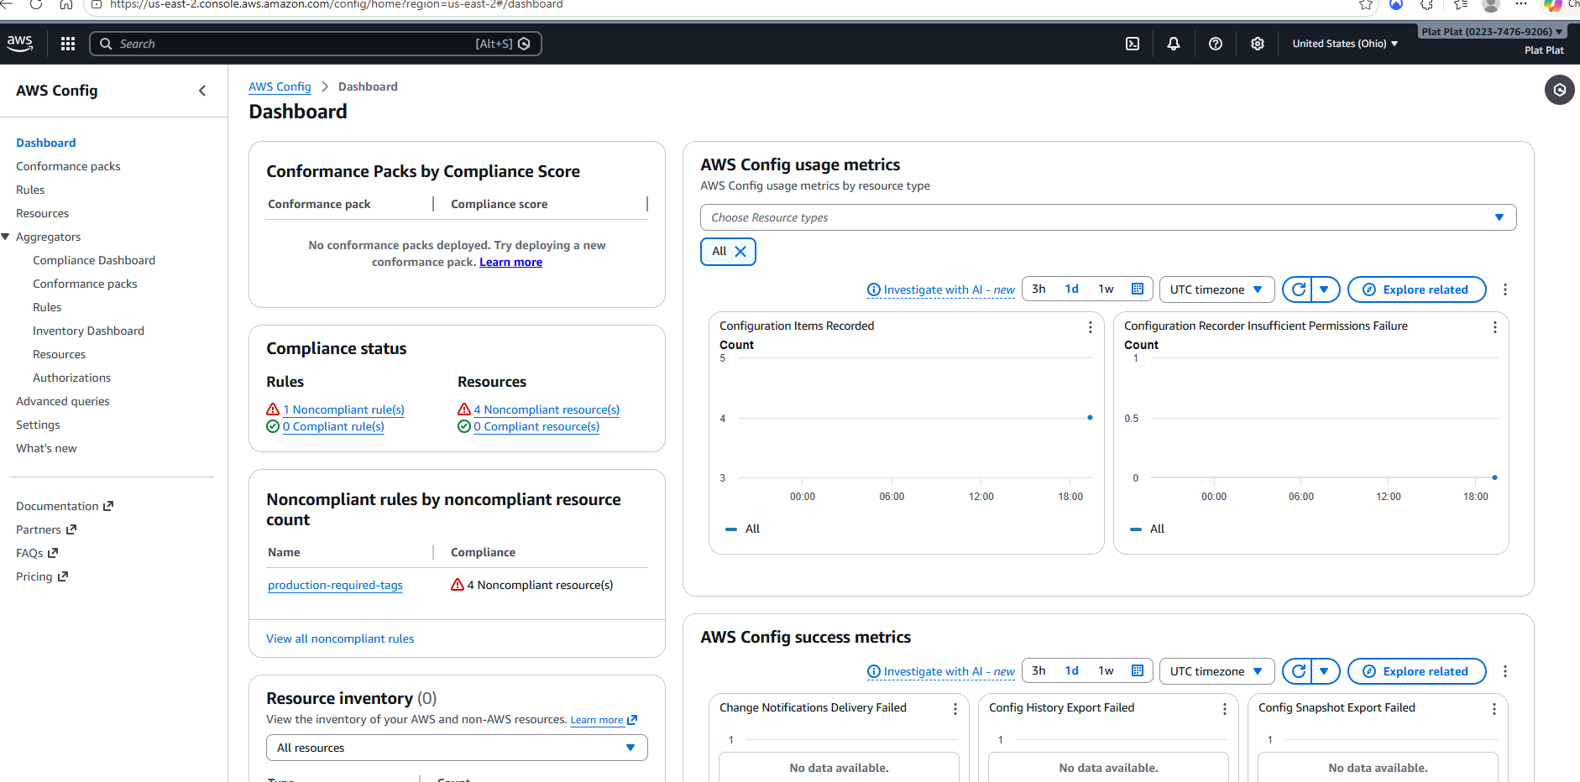

Lambda functions
